Monthly Parish Meeting – DRAFT Minutes
Councilors met for the Annual Parish Meeting on
Wednesday the 15th of November at 7.30pm at the Bulkington Village Hall
Present: Andrew Grabham (Chair of meeting), Julie Anderson-Hill, Alex Breach and Carla Haslam

Ref | Agenda Item | Action
1 | Apologies for absence: Alison Howard Evans, Philip Oakey and Tamara Reay
2 | To Record:  No changes to the Register of Interests were made  Alex expressed his interest in Agenda item 5 and the planning permission discussed is for a family member. No other interest in Agenda Items was declared.
3 | Report from Tamara Reay: Tamara was unable to join for the meeting but kindly shared her updates:  Wiltshire Council Finances  Wiltshire Council has provided its second formal financial update reports for the 2023/24 financial year, and is continuing to manage its budgets responsibly amid the continuing unpredictability of the national economy and the ongoing pressures faced by all councils. At the end of the second quarter there is a small, forecasted underspend for the year of around £0.4m, which has changed from the £0.3m annual overspend which was forecasted at the end of quarter one.  This is a positive position to be in, and reflects the council's careful financial planning, and this position will continue to be carefully monitored as there are a number of risks that could affect the council. This includes sustained higher inflation than was budgeted for, increased demand and higher package costs in the council's people services, SEND (Special Educational Needs and Disabilities) transport and less income received so far across some of the council's place services, such as parking and planning.  More than £26m of savings were identified to be made during 2023/24 and, at the end of the second quarter, more than £7m has already been achieved (around 27%) with a further £17m on track to be delivered (around 64%). The council will continue to robustly monitor its finances and focus on the delivery of savings. The council has taken a long-term strategic approach to its budget, which included effectively setting the next three years' budgets in February, and this means it is in a stronger position to respond positively to any unexpected issues.  Ask The Leader – Melksham: 28 November 6pm-7:30pm  Cllr Richard Clewer, Leader of Wiltshire Council will host the next “Ask The Leader” event in Melksham on Tuesday 28 November (6pm-7:30pm). The event will take place at Melksham Campus in the library and residents can ask any questions about the council, its objectives and priorities, and the challenges ahead. The events are an opportunity to put questions directly to the Richard Clewer, and hear his thoughts and plans for the future.  Flooding Issues  The recent weather means that flooding continues to be an issue across the area – although I am not aware of any specific issues in Bulkington. In Devizes Rural West there are particular issues in Potterne and Erlestoke and I am working with these Parish Councils and Wiltshire Council to secure improvements. As always, blocked drains, gullies and everything else should be reported on MyWilts.
4 | Local Police Report:  The local police department shared the first of a new set of reports this month, updating on local PC changes and Key incidents in the area. PC Elliott Holdsworth is now our local PCSO. Key incidents reported in the area are listed below:  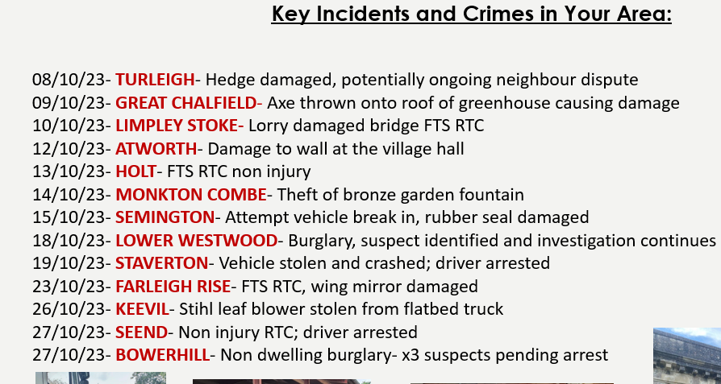 | Clerk to report vandalized park bench seat request assistance in monitoring the area.
5 | Open Forum: The Environment Agency Complaint on Mill Lane was discussed. A villager has complained to the Environment Agency about some gates installed by Robert Breach. The gates allow vehicle, pedestrian and horse access and crushed stone sourced locally reduces the mud. The posts were installed using concrete. The Environment Agency have tested the stone used for the pathway and found traces of asbestos. The top layer of the stone will be removed and disposed of and the area will be covered with an alternative crushed stone material.  Due to this incident, farm gates will now remain closed. Villagers are requested to restrict their movements to the footpaths.
6 | Local Planning Updates:  No comments raised:  Bulkington CP Application Ref PL/2023/  08083 - Removal or Variation of a Condition Address: Land adjacent to Ashatch Farm, Mill Lane, Bulkington, Devizes, SN10 1SP Proposal: Variation of conditions 2, 4, 5 and 7 of Planning Permission PL/2023/01321 - to allow alternative design of approved dwelling to single storey, 2 bed dwelling plus alteration to orientation Applicant Name Mr Mark Elliott Case Officer: Selina (Nina) Parker-Miles Respond By 01-12-2023 Application Link: https://development.wiltshire.gov.uk/pr/s/planning-application/a0i3z00001BD1qr  No comments raised:  Bulkington CR Application Ref PL/2023/09386  Application Type: Householder planning permission  Proposal: Front porch extension (to replace existing porch), and rear single story extension to provide utility, larger kitchen and dining area  Site Address: Bay Tree House, 23 High Street, Bulkington, Devizes, SN10 1SL
7 | Minute Approval: The minutes of the last meeting of the Parish Council in October were approved as a true record.
8 | Finance:  Clerk Pay £325  Grass cutting £228  Clerk expenses (printer Ink, heating costs for village Hall, folders for paperwork) £25  New Bin through Ideverde £193.05 + VAT  Adult Disposable Defib Pads £156.00  Paediatric Disposable Defib pads and long life battery £348  TOTAL in PC account 21.11.23: £11,953.07  Finance Heads up:  - Clerk Pay Scale update: Increase of hourly rate from April 2023 backdated.  - Precept coming up, due mid Jan 2024 | Clerk to pay suppliers
9 | Recreational Ground:  - Update on the ROSPA inspection – The ROSPA report highlights a potential risk on the zipline due to the age of the item. The Parish Council will follow the advice in the ROSPA report and will get the item inspected.  - Update on the new play house and trim trail that have now been ordered: Currently scheduled to be delivered, (not installed) week commencing 4th December.  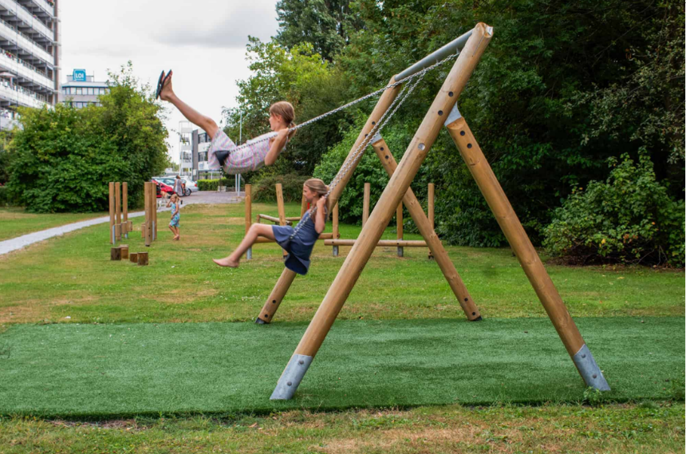  - Update on the new swing: A range of quotes have been considered, two side by side swings, age 3-14 have been selected, with a wooden structure (more cost effective than a metal structure) with metal feet to allow for safe grass strimming and its location on boggy ground was decided upon unanimously. The wooden swing, with a grass lock included, will cost £5697, however an onsite visit will be required before the company will commit to a final cost. It was agreed that this is the more sustainable option that is in keeping with other playground equipment. The Rec Ground funds will be used towards this, along with the ring fenced funds from last year’s precept. Steve Kerslake has generously offered to donate £1000 providing the order is placed before the end of December. The Parish Council would like to take Steve up on this generous offer.  - Carla informed the Parish Council Team that a new lock has been placed on the Rec Field to prevent fly tipping. Carla will be reimbursed for the £25 used for the lock from Roses from Rec Ground funds.  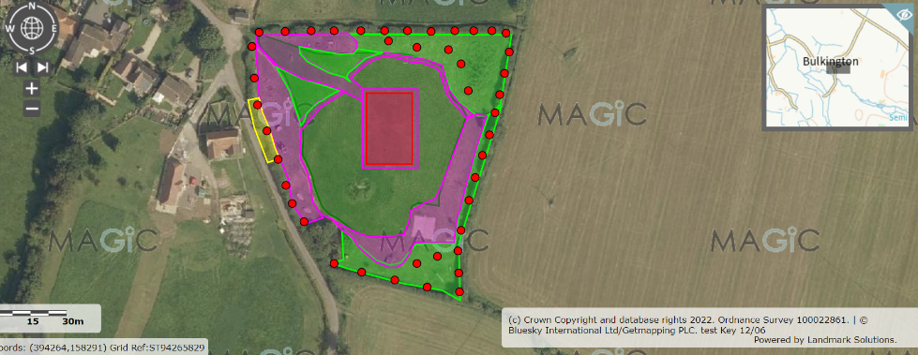  - Tree Planting proposal: Councillors agreed to move forward with the tree planting. The below is a draft planting plan, The areas are not to scale, or showing actual layout shape or representative of tree numbers.  Red – individual parkland trees such flowering cherry, silver birch, field maple, oak, etc. or perhaps a linear orchard or combo of both.  Light Green – understory planting such as viburnum, crab apple, hazel, yew, spindle, privet, dogwood, holly, etc… approx. 0.2 hectares in total  Yellow – natural hedge mix  Purple – amenity cut grass @ 15 cuts per season to enable unrestricted access  Dark green – meadow cut grass. Annual cut and collect (free hay for a nice local farmer if they cut it for nothing perhaps?)  - Recent vandalism in the Playing Field has resulted in a new bench being removed and requiring replacement. Please stay vigilant and report any unusual or suspicious activity to the police who are aware of the matter. | Clerk to arrange inspection  Manor Farm Bullkington address for delivery  Andrew to contact the swing company to inquire if a reduction in price is possible  Clerk to post about broken bench and tree planting proposal on Facebook and website  Clerk to check insurance for reporting of bench
10 | Parish Steward: Outstanding jobs to be sent to The Clerk prior to next visit. Last visit was 6th of November and next visit is 4th December. The Clerk has reported the overgrown pavements and mossy areas, especially in the entrance to The Close and has requested hand clearing of all drains and that a sweeper attend the village to clear the debris. | Clerk to chase Steward and escalate the requests that have not been actioned
11 | Recruitment: We are currently recruiting for a Clerk and one Councillor to join the team, if you would like to put yourself forward, please email our Clerk Hannah.  Closing date for applications is Monday 20th November, interviews will then be conducted.
12 | Emergency Team updates:  Andrew reported that the Salt Bin still has sufficient Salt in for the winter and will not require refilling. | Alex to check the other winter supplies in the Emergency Store.
13 | Defibrillator:  Updates from Philip: purchases have been made to replace the used adult pads, obtaining a second replacement adult pad, that I’m storing at home, and the out of date child’s pads. In addition, the out of date battery has been replaced. Invoices for these have been sent to the clerk for reimbursement.  A system of checking the items has been put into place and a log is being kept in line with the recommendations of SouthWest Ambulance Service (SWAS) The monthly confirmation to SWAS for 1 November has also been made and acknowledged by them. Notices in the Defib box indicate that I should be made aware if the equipment is used. In addition the various pads have also been marked to show who they are suitable for I.e. those under 8 years and those 8 years of age and older. | Clerk to re-imburse Philip
14 | Remembrance day: Andrew laid the wreath on behalf of the Parish Council, councillors praised the new fence and thanked the volunteers who cleared the War Memorial in preparation for the event.
15 | Councillor Training: Councillors re-read the Standing Order document on Bulkington Website and the Good Councillor’s Guide as a refresher. All confirmed that, as a team, Councillors need to agree on meeting protocol and rules including engagement with villagers attending the Parish Council meetings to ensure these can run as smoothly as possible. | Councillors yet to read the document to complete reading
16 | AOB:  - Chestnut Drive and Northfields curb drop: Traffic Engineering Manager Gareth Rogers gave the following update: Just to let you know that Milestone have been to lift the service covers at in Bulkington. The levels of the service cover at Chestnut Drive can be adjusted to suit the new footway gradient following the installation of dropped kerbs. At Northfields, the services are shallow so we don’t have the option to lower the original stone kerbs as they are too deep. Any kerbs that are installed need to be shallow and securely set in order for them to stay firm and not impede the shallow services.  Councillors confirmed that the existing kerb stones can be replaced with standard pre-cast concrete kerbs. These are already present on the opposite side of Northfields junction. The dropped kerbs on the opposite side could do with being realigned slightly.  Whilst the Milestone agent was on site checking the services he had some concerns about the width of the carriageways on both junctions, particularly given farm vehicles use this route. He has requested a meeting with the traffic management company to discuss what method of traffic management is most suitable.  - Newsletter progress update: Newsletter is in Draft Form, additions were discussed including: tree planting proposal, park vandalism, drop kerbs.  - The material dumped in the playing field for the bonfire will be burnt off when dry. | Clerk to feed back to Gareth Rogers and give go ahead  Carla to send rec updates and pictures to Julie
 | Next meeting: 13th December 2023 at 7.30pm.

